# Lab 1:((creating Ec2 instance):

# ®Login to AWS console.

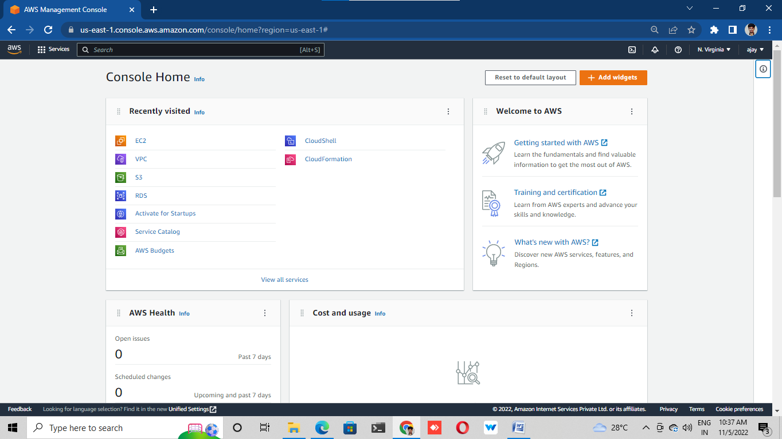

# ®Creat a server with amazon linux 2 AMI

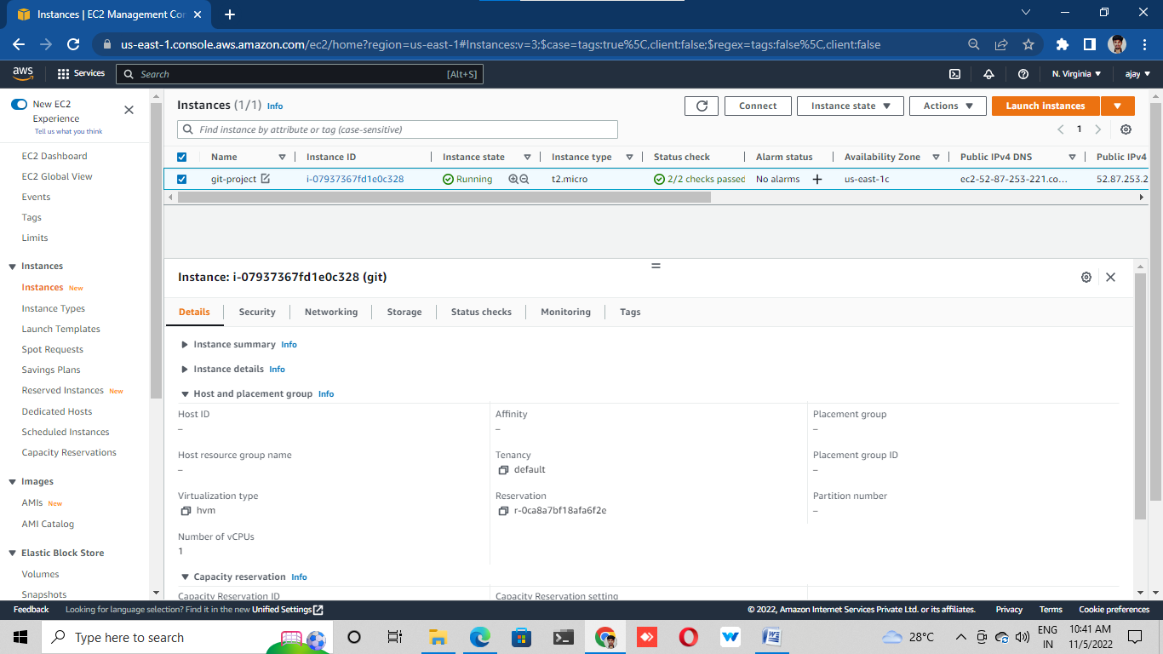

# Connect the server with Putty/GitBash.

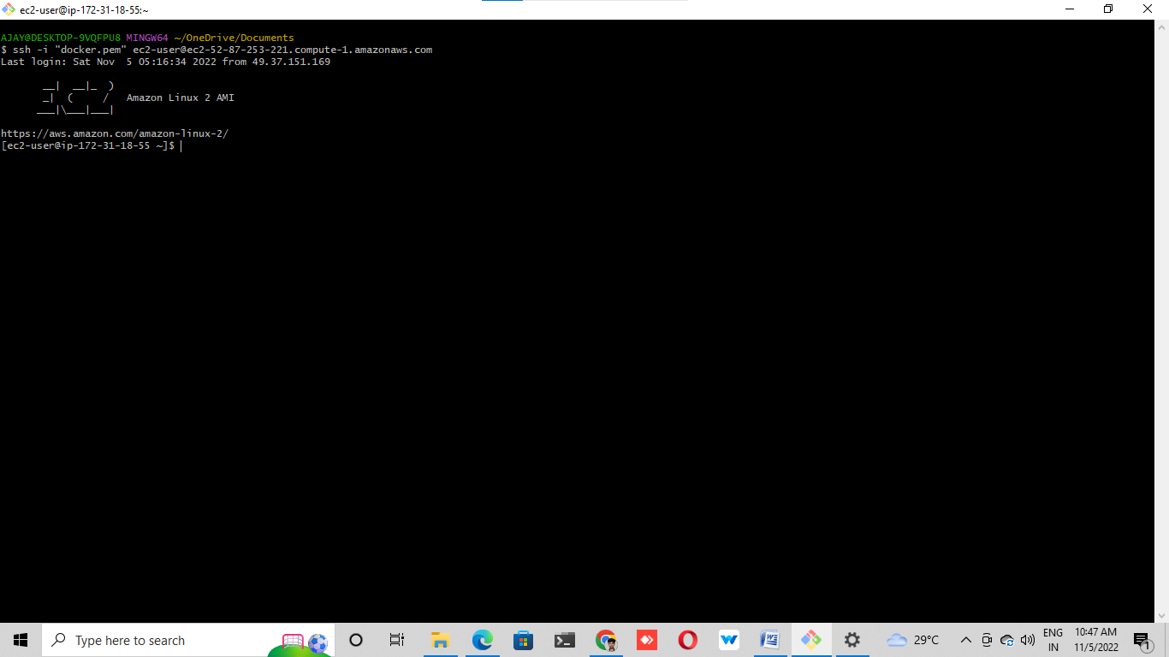

# LAB 2: (Create repo in local machine):

# Create a folder on my local machine

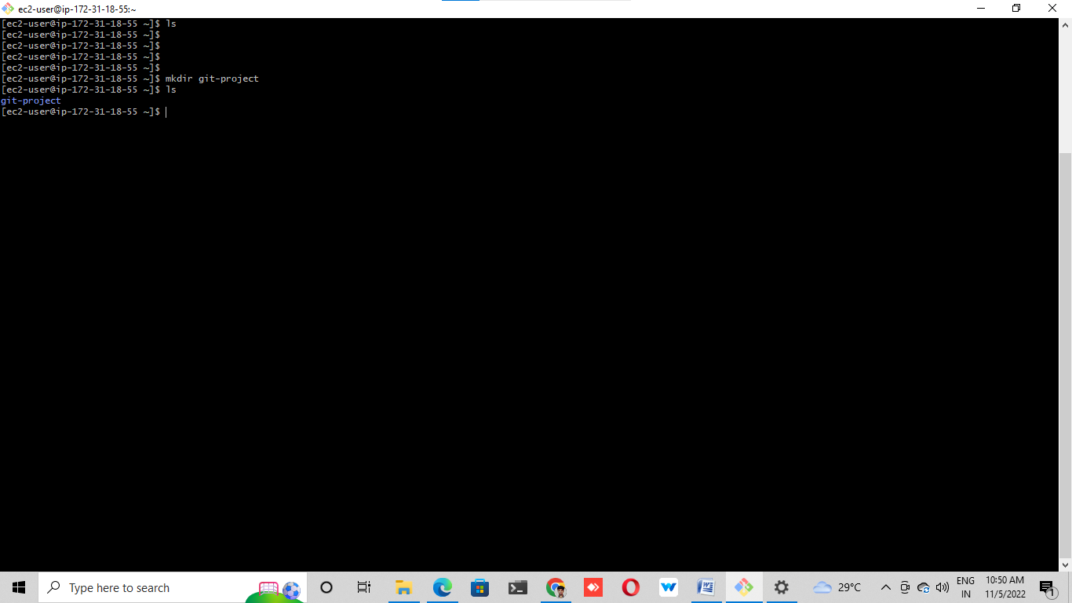

# initialize this folder using git init command

# a. --> git init<folder name>

# b. Go inside this folder and run git status command to check the status

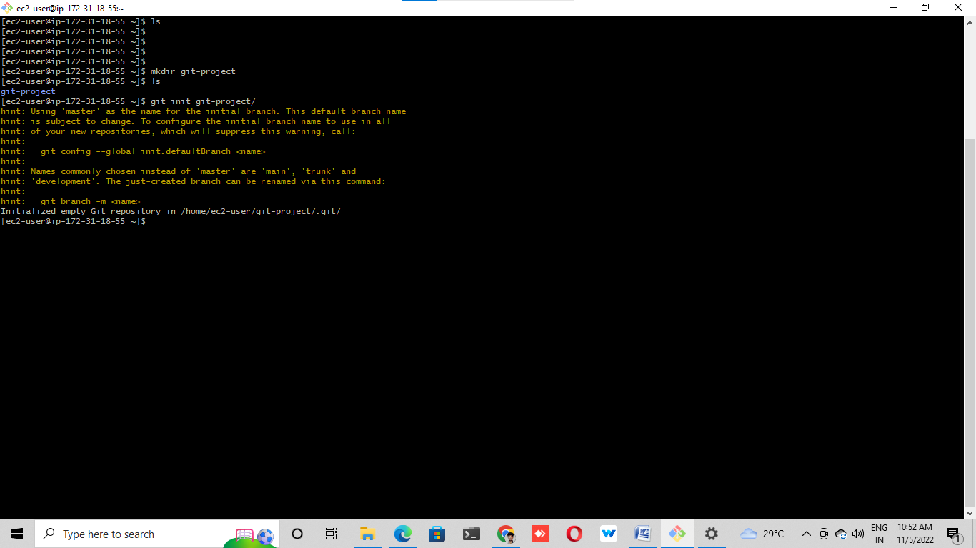

# created some empty files using touch command

# a. --> touch test

# b. Again, run git status to see the changes, you can notice that the file is available but not tracked by Git

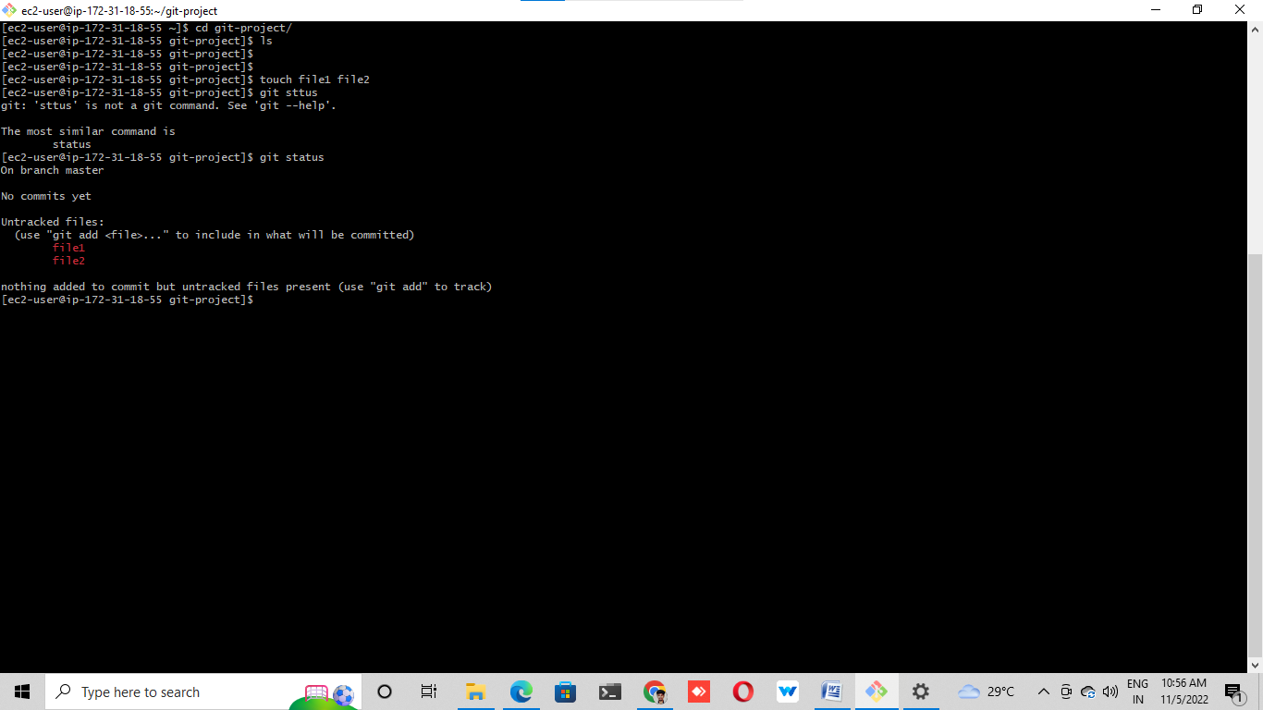

# Run git add to stage this change (git will start tracking this file), you may check it using git status once again.

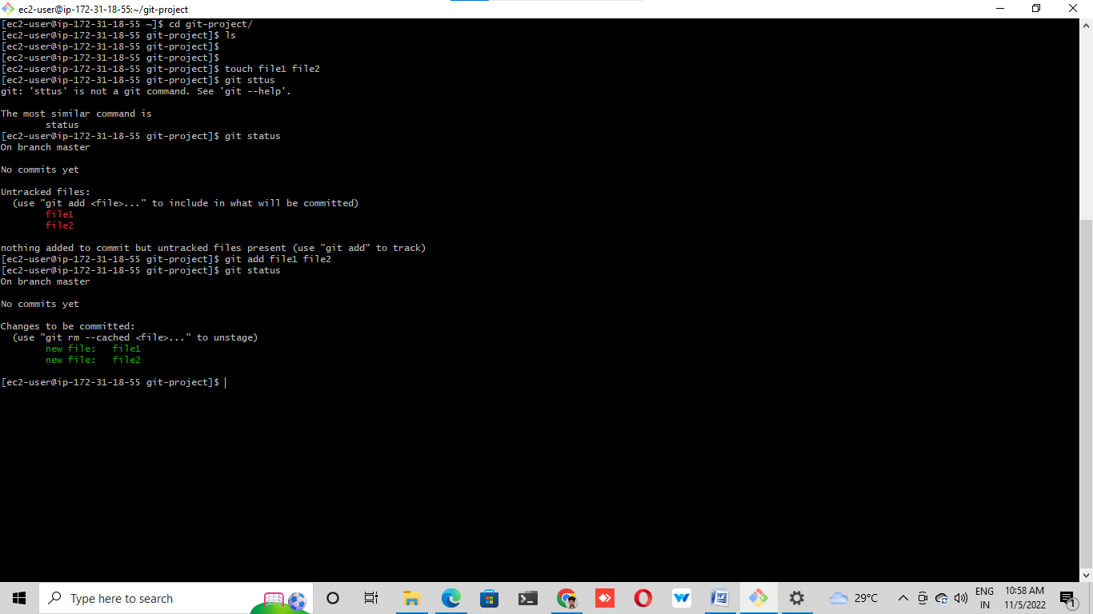

# Now commit our changes by running git commit -m "added test files"

# Run git status once again and it will show you that the working tree is clean.

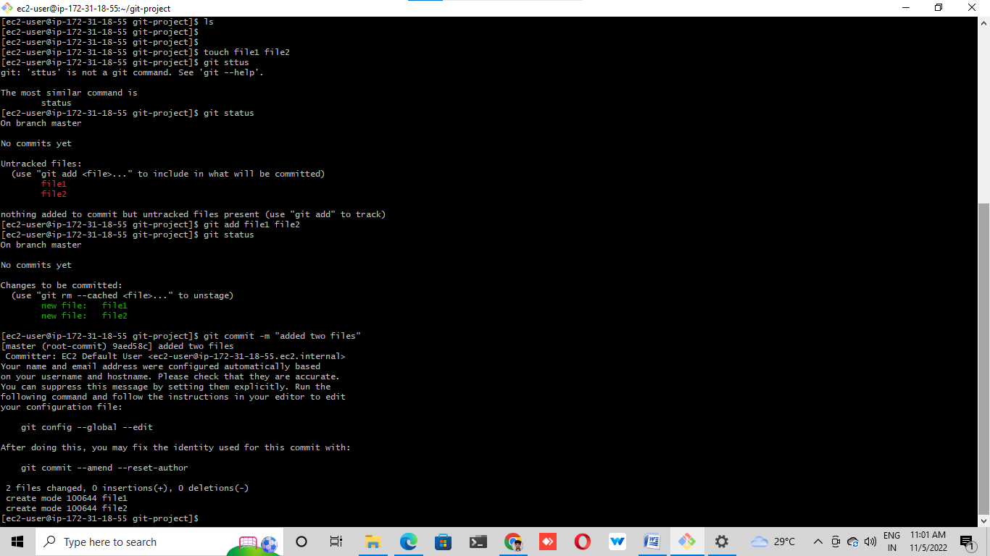

# LAB 3: (Creating repo in remote location – GitHub):

# ➢ Now create a new repository by clicking on new button

# a. Provide repo name

# b. Select whether it is a private or public repo (recommended is private)

# c. Initialize the repo by adding a README.md file.

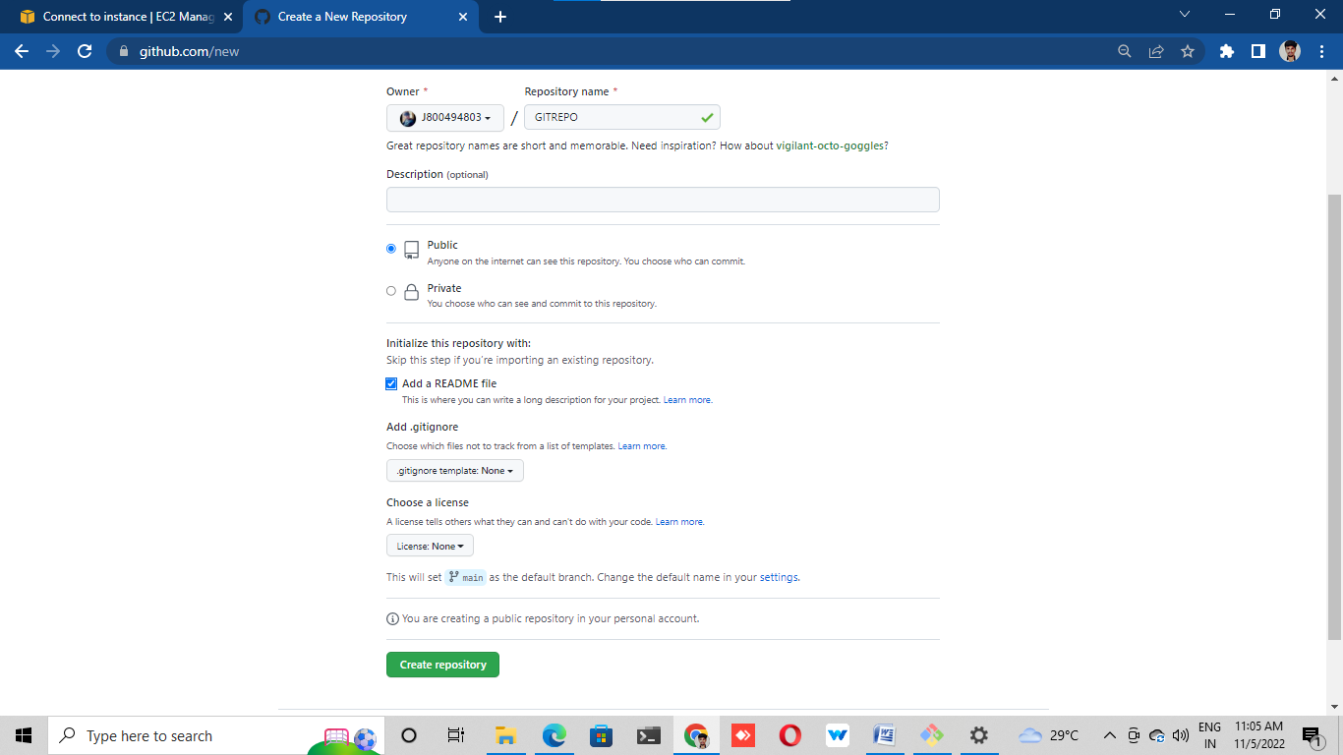

# Click on create repo and done.

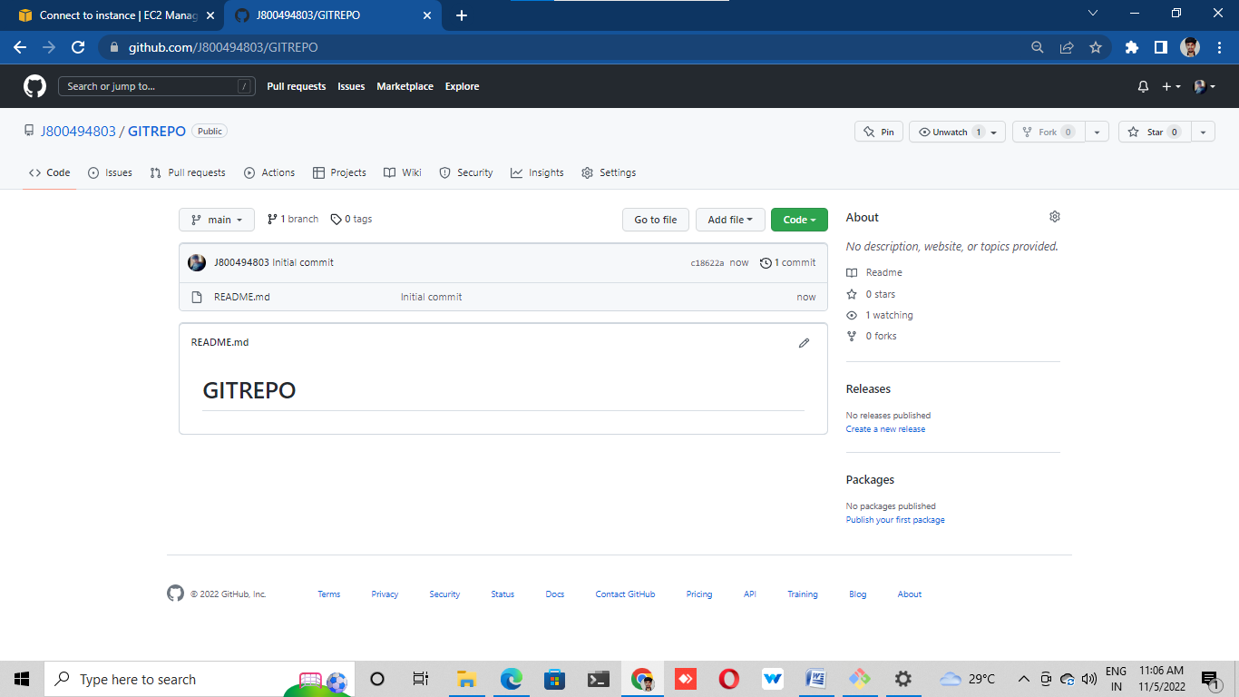

# LAB 4: (Working with Remote repo):

# ®Pick the clone URL of the repository from the GitHub repo.

# ®Go to your local machine and clone this repo using git clone command

# A. git clone<repo URL that you will get by clicking on code button in GitHub>

# B. Here you will get one error for password-based authentication

# depreciation.

# C. Now, we need to create the personal access token to work with this repo.

# D. At the top right corner click on the user icon

# E. Go to settings c. Developer settings

# F. Personal access token

# G. Click on generate token

# H. Provide a note

# I. Expiration date and scope (select the very first checkbox for scope)

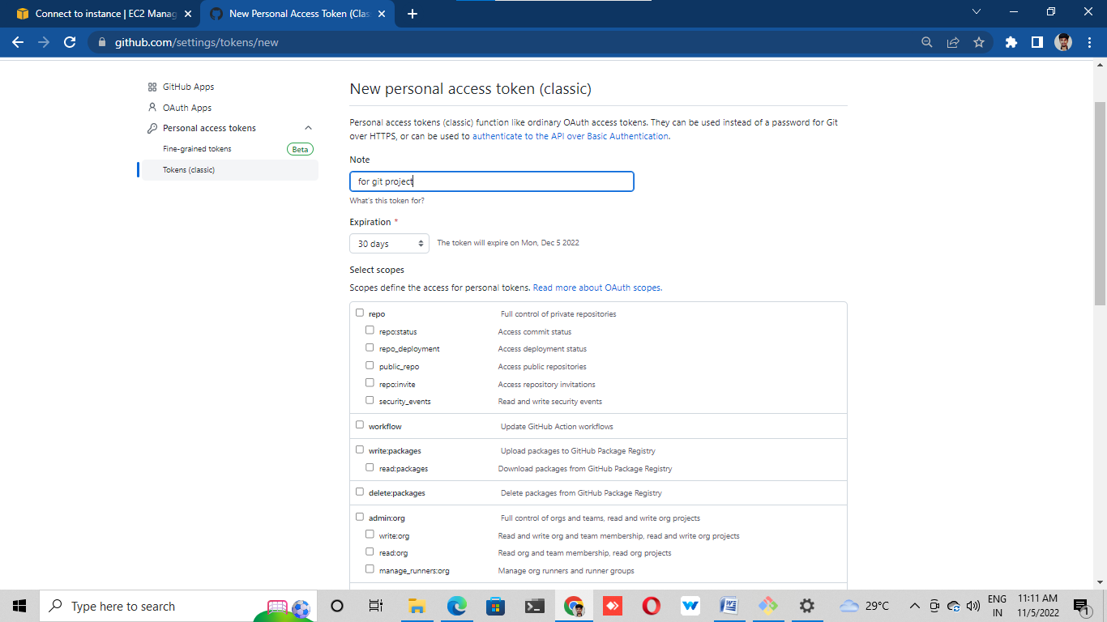

# J. Click on generate token

# K. Copy this token and keep it safe

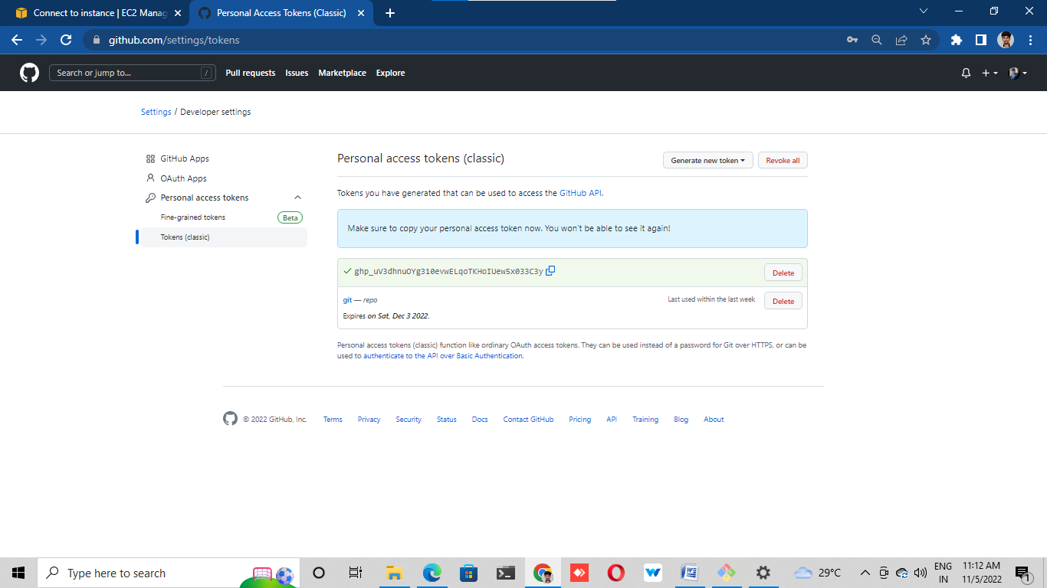

# ® Clone the repo again in your local machine, and this time provide the token in

# place of password while cloning.

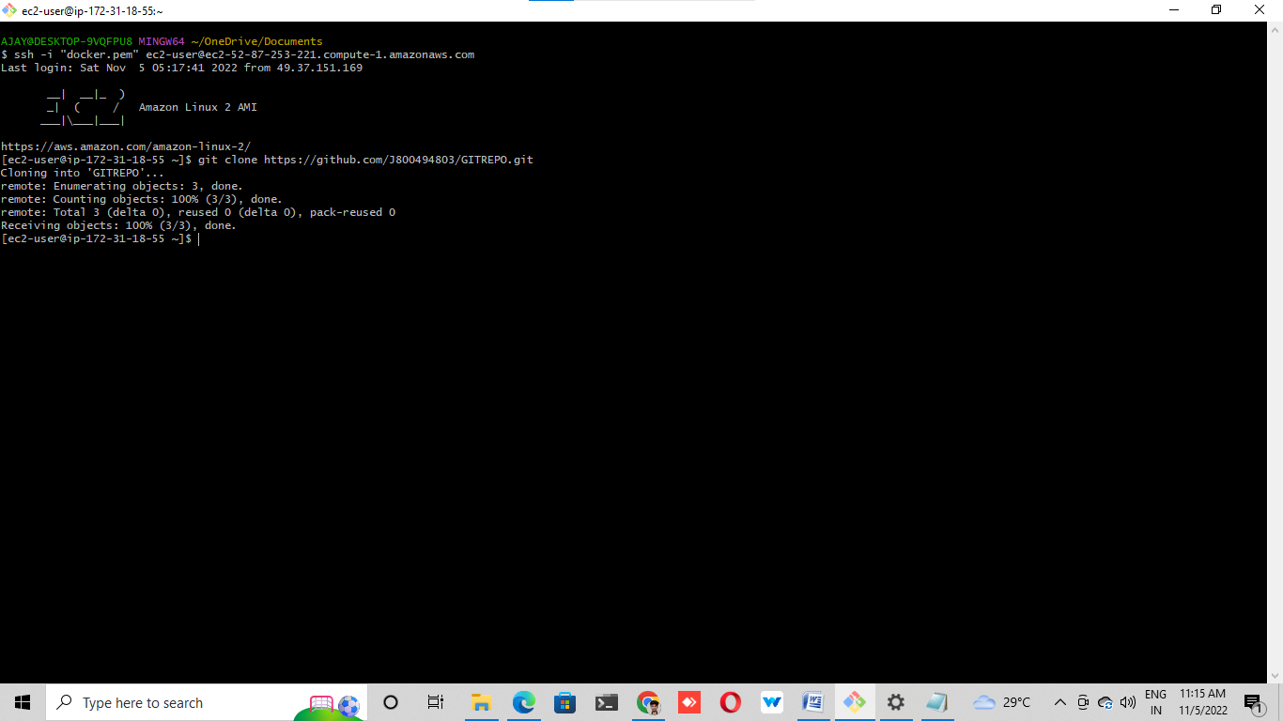

# ® Once cloned, go to the repo folder and add some sample files. We can use touch

# command to create empty files.

# a. touch text1 text2

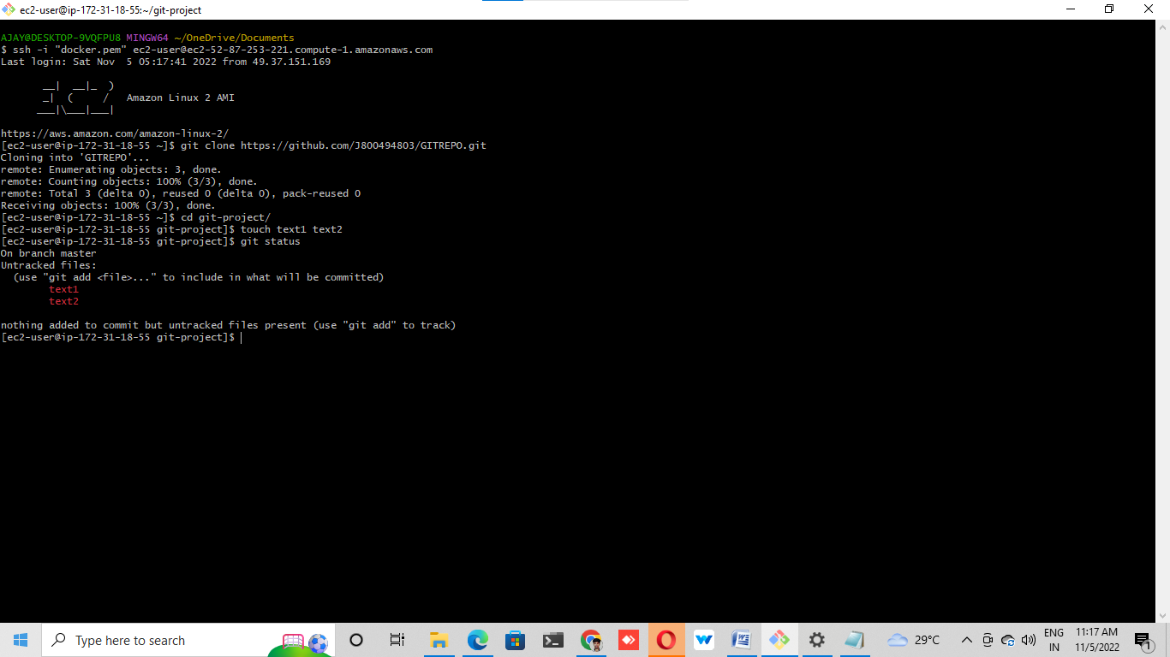

# ®Stage these changes by running git add text1 text2

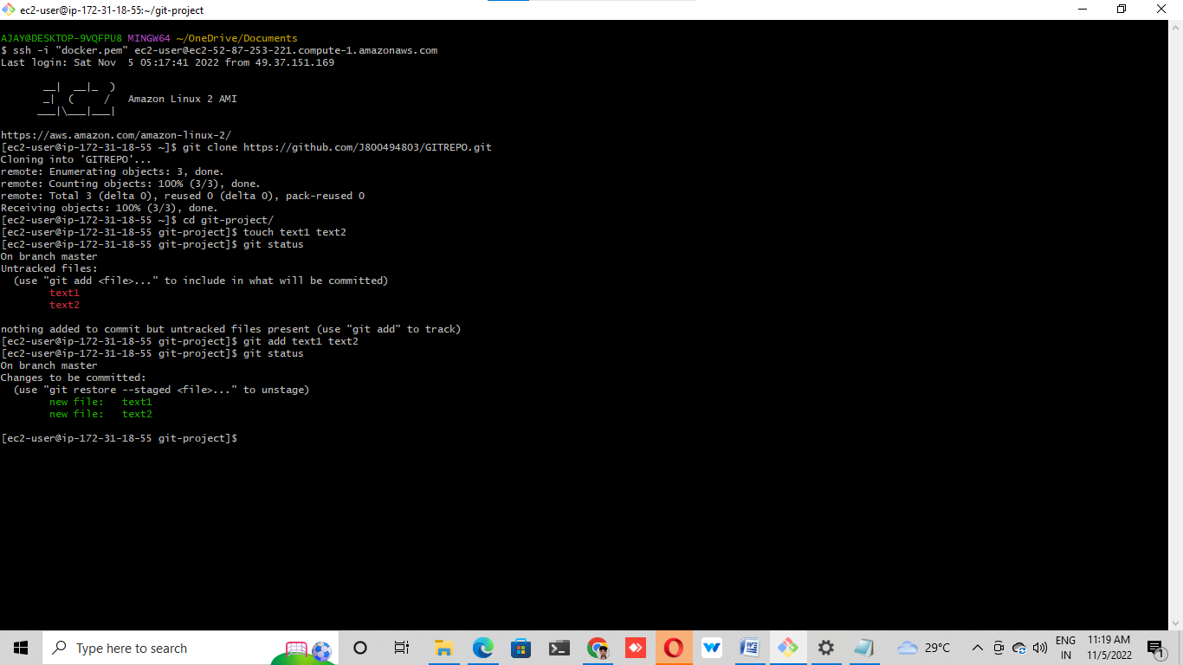

# ®Commit these changes by running git commit -m ""

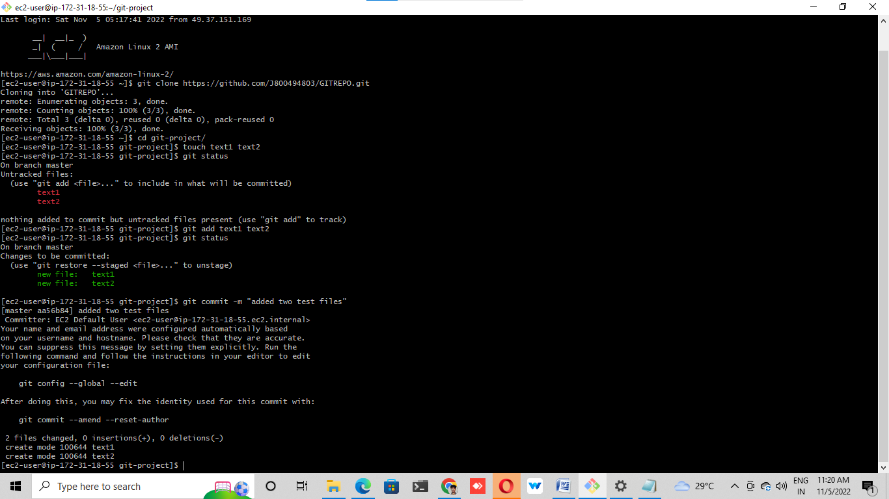

# ®Git push --> it will ask you for username and password, provide the username and

# personal access token in place of password which we created above.

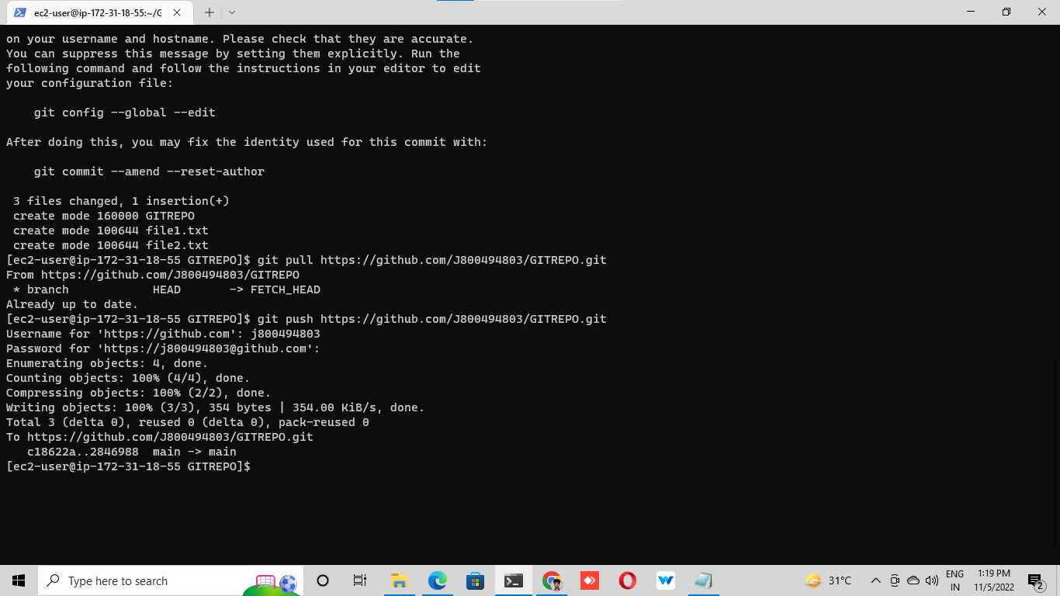

# ®Go to the remote repo and see, you will be able to find your new changes.

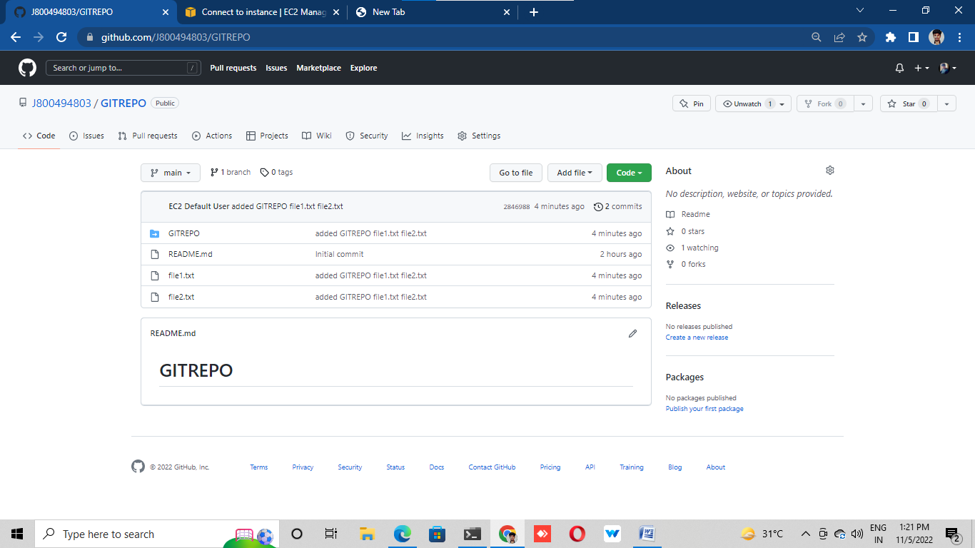

# LAB 5: (Pushing a locally created repo to GitHub):

# Create one repo in our local machine and initialize it locally (we have done it in Lab-2

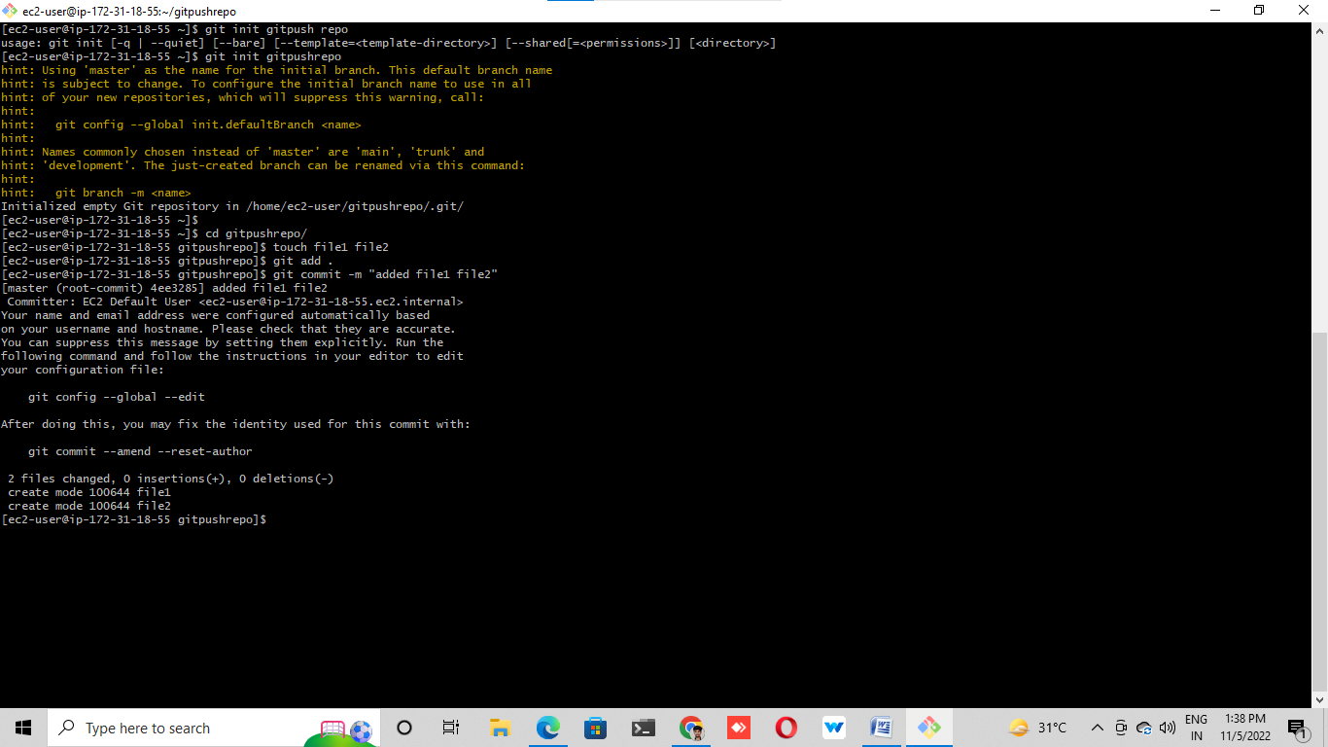

# ®Create one remote repo with the same name as local repo in GitHub and do not

# initialize it

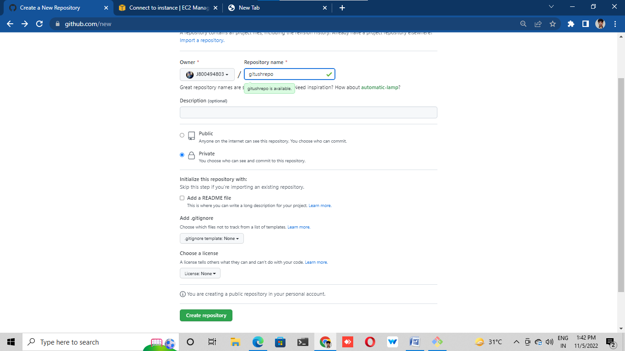

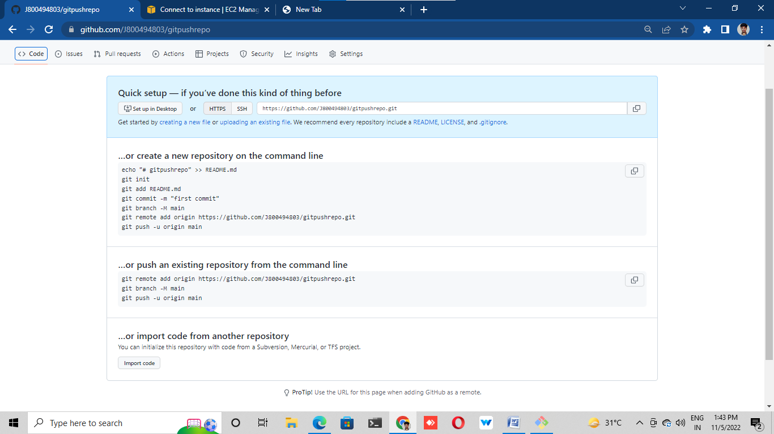

# ®Come to your local machine and run the following commands from inside your

# local repo (Lab – 2)

# a. git branch -M main (to change the name of branch as master branch is now

# known as main branch).

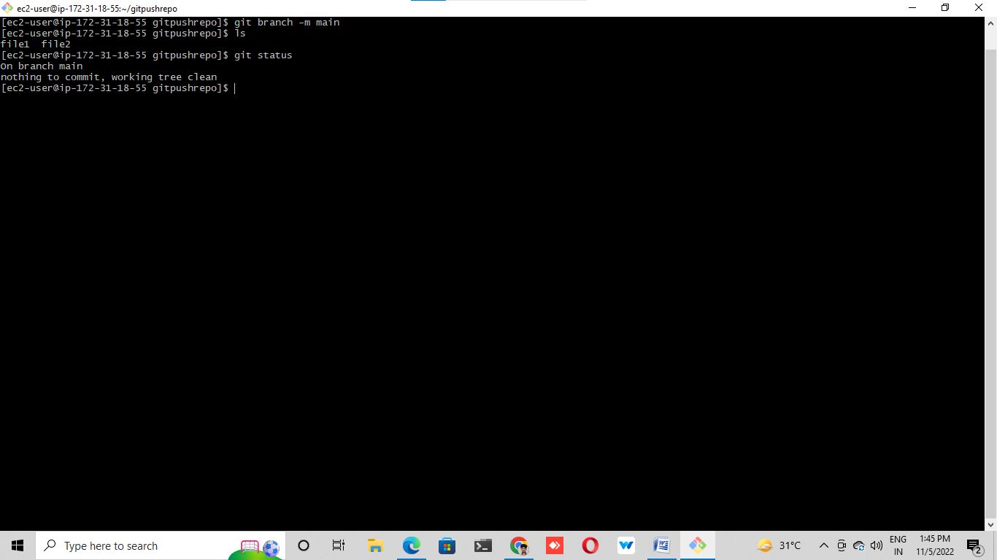

# b. git remote add origin <URL of your remote repo>

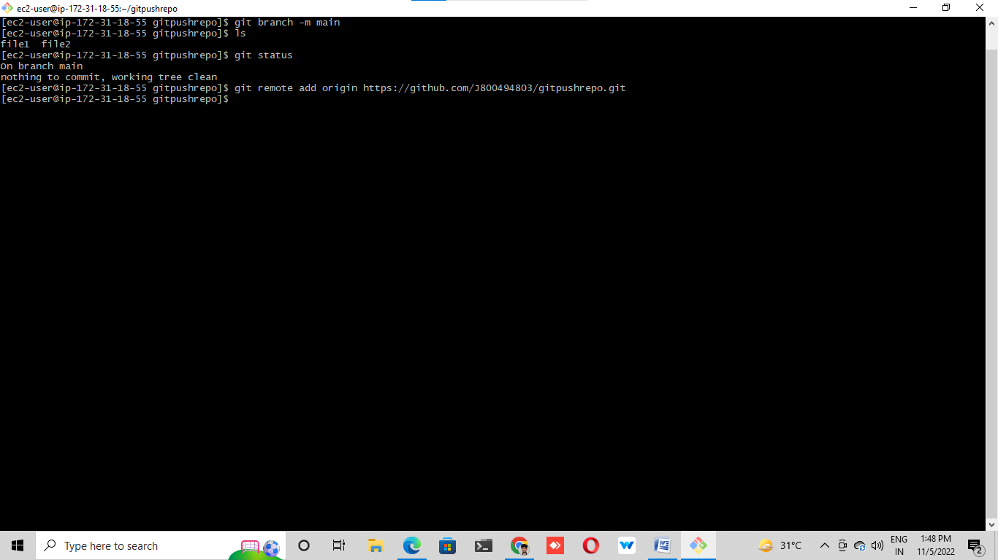

c. git push -u origin main (to push your local branch to remote repo)

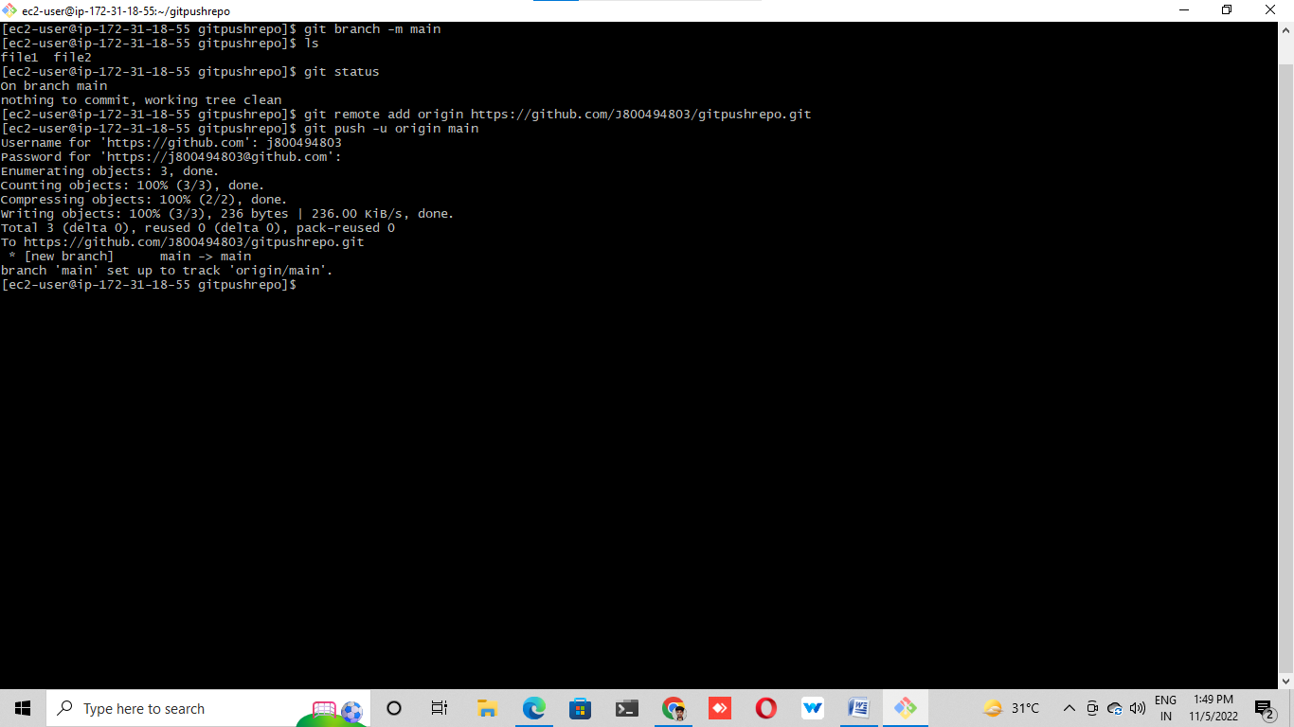

# LAB 6: (Creating a new branch from your main branch):

# ® Go to the repository at the place of main and click on the branch dropdown.

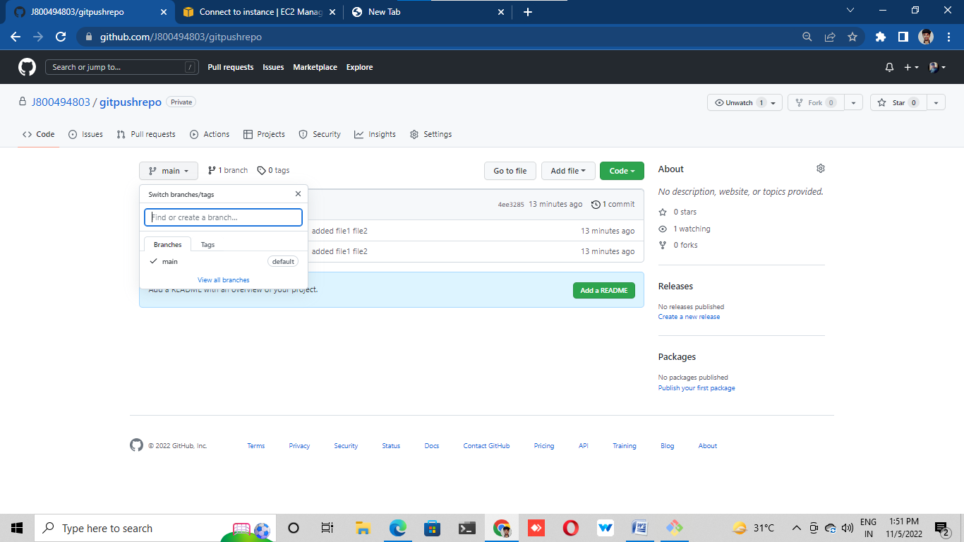

# ®Type the name of your new branch that you want to create and click on create

# button.

# ® A new branch will be created for you “gitpushrepo”

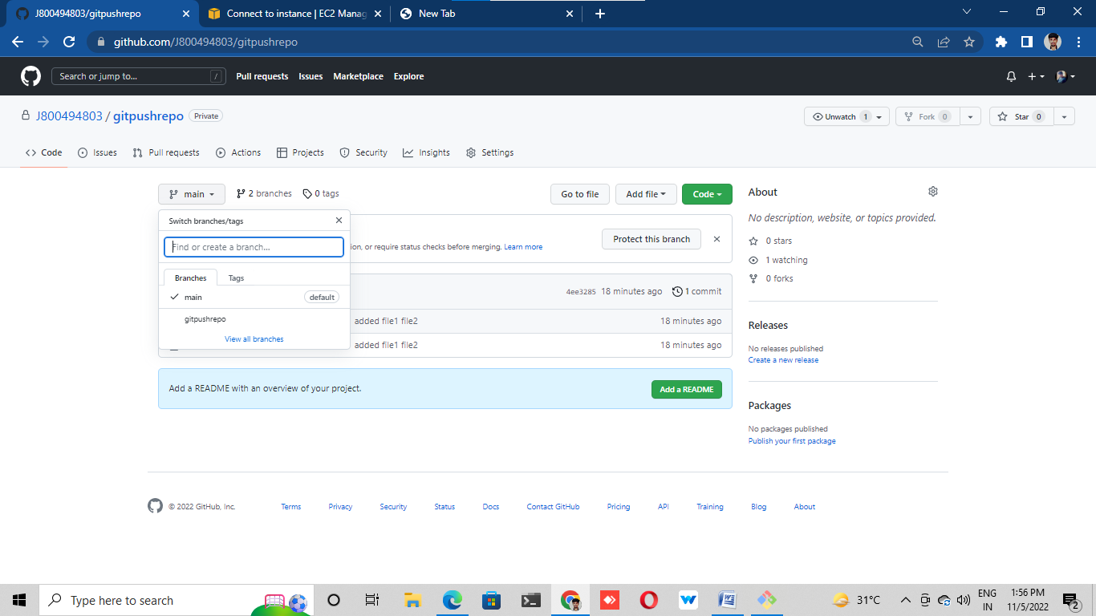

# Make some changes in this branch directly from the console

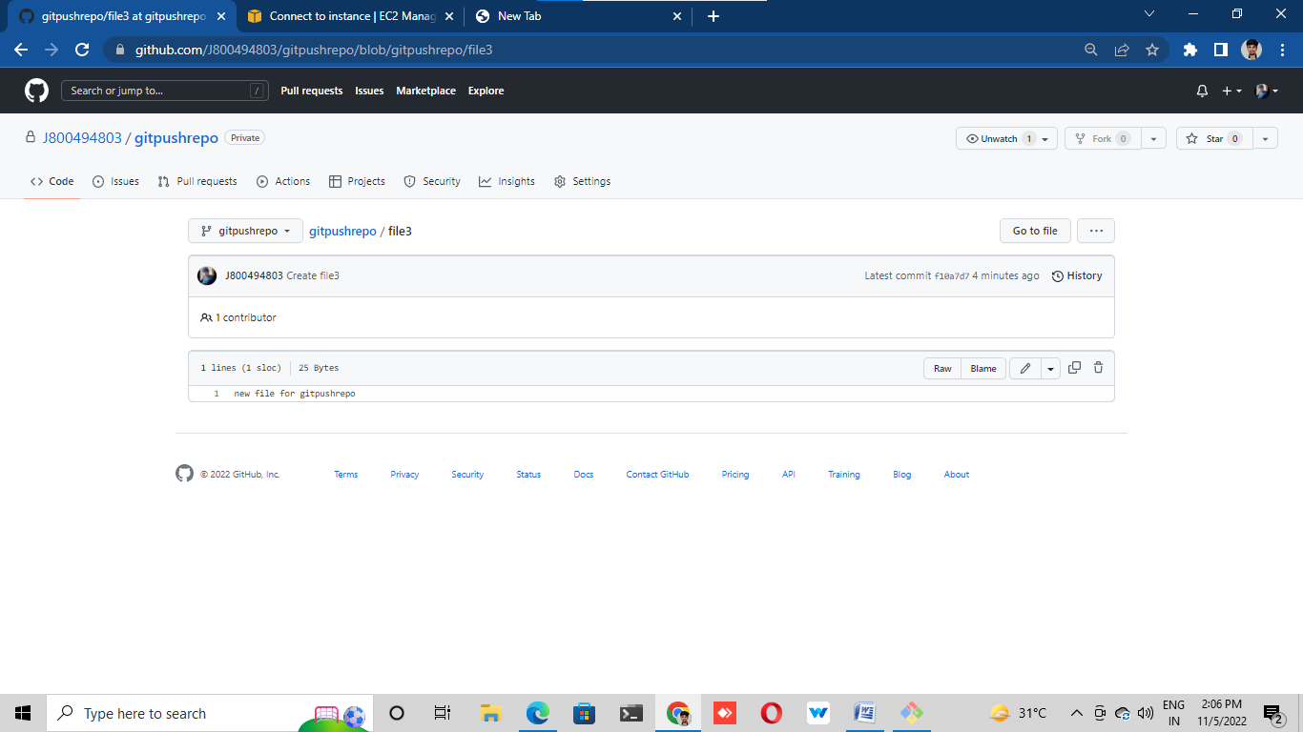

# Here you will see that your changes are only applied to your new branch but not to

# the main branch.

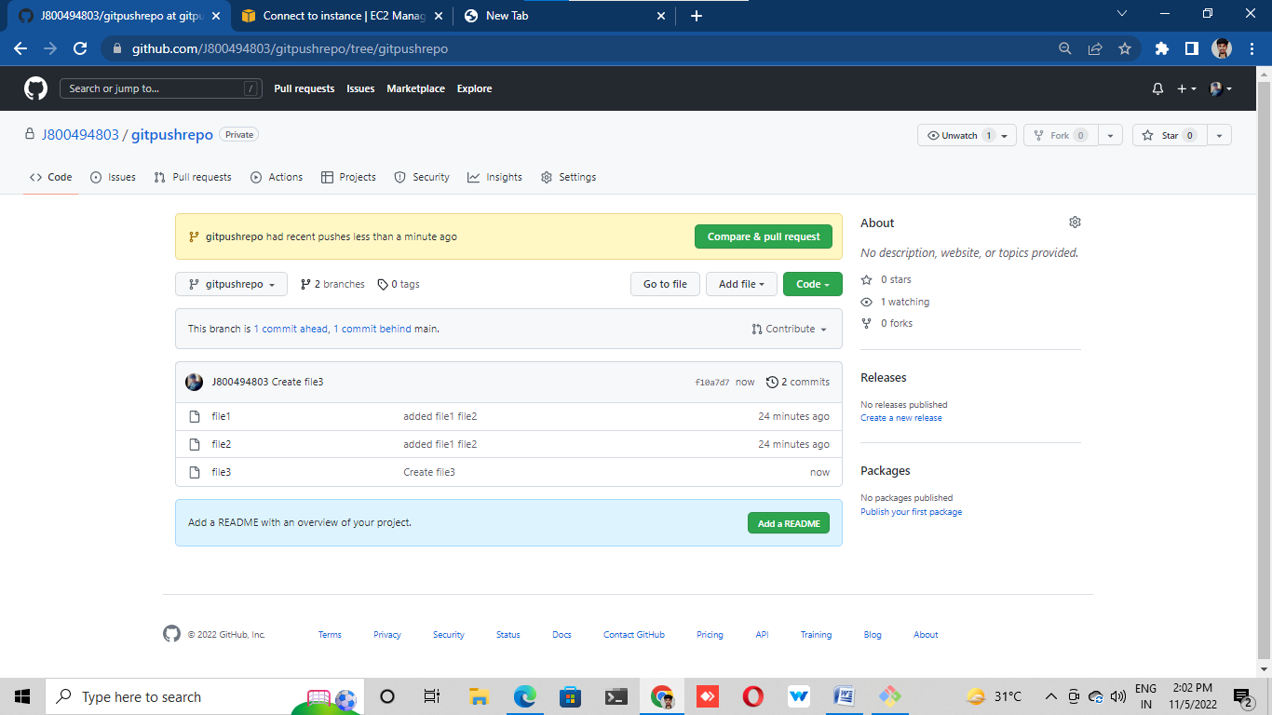

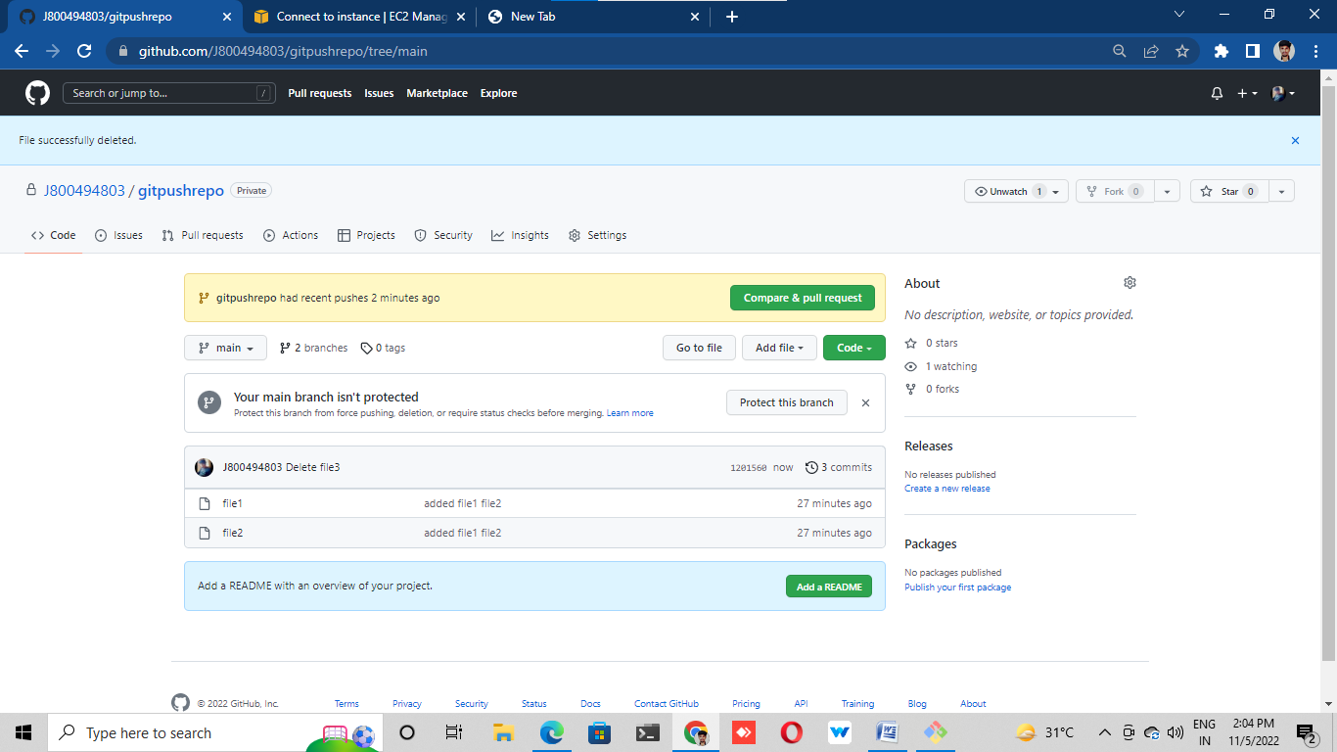

# LAB 7: (Pull all the branches in your local machine):

# Go to your local machine where you have the copy of your remote branch (Lab – 4).

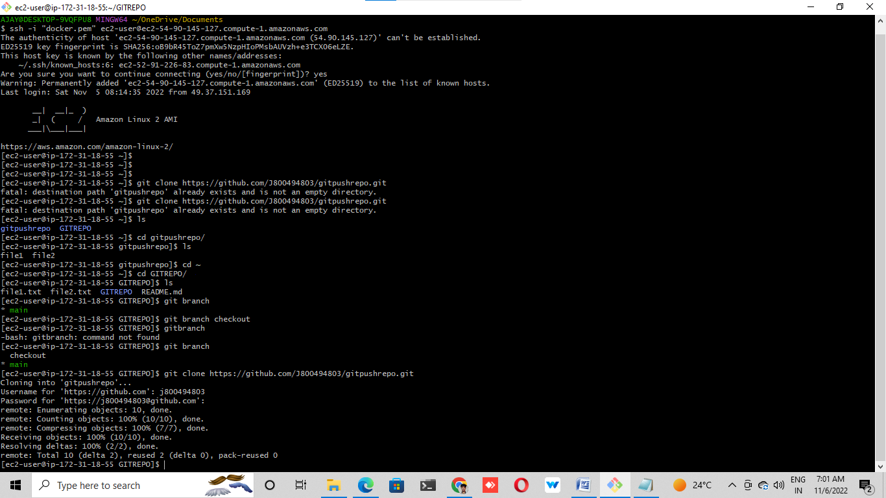

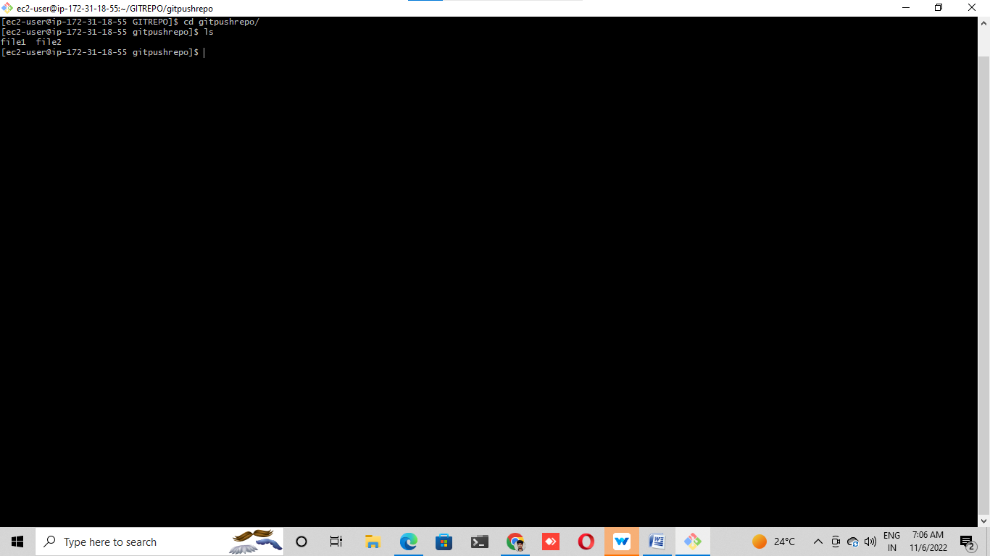

®Run the command "git pull" to pull all the new changes such as branches from the remote location

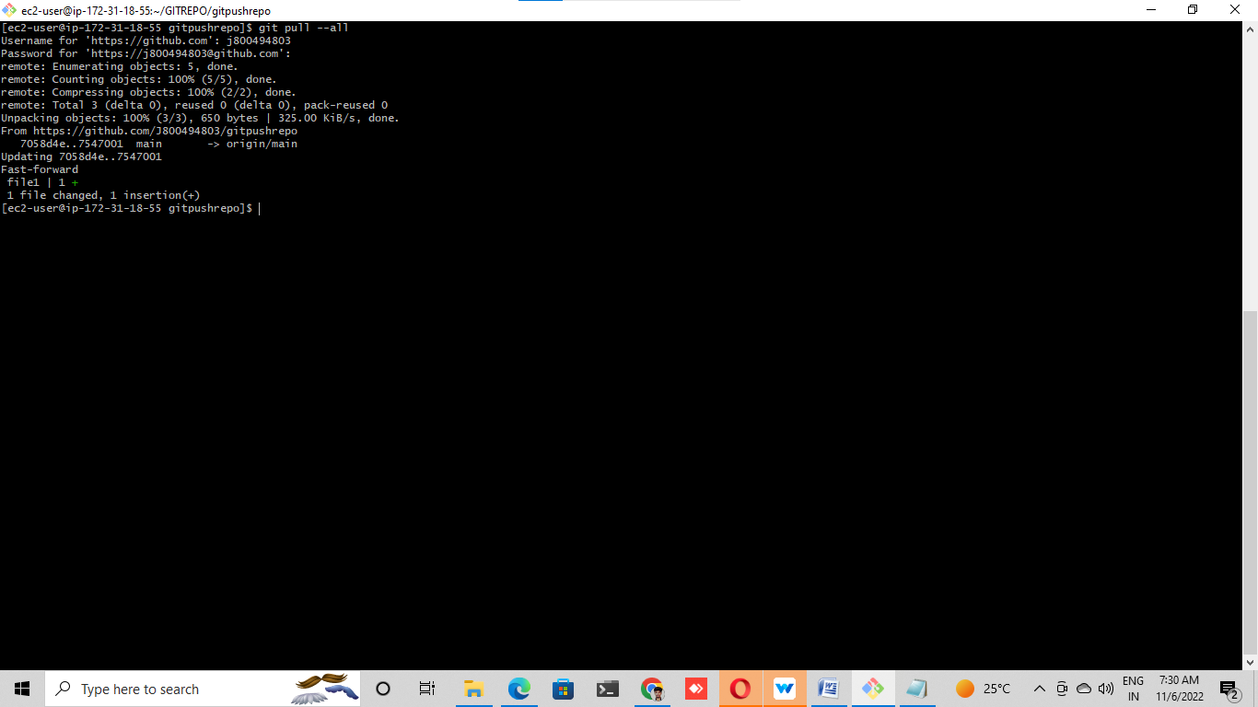

# ®Run "git branch -a" to list down all the 3 branches.

# a. The branch which starts with remotes/ ---> are remote branches

# b. The branch without remotes/ ---> they are available on your local copy as well

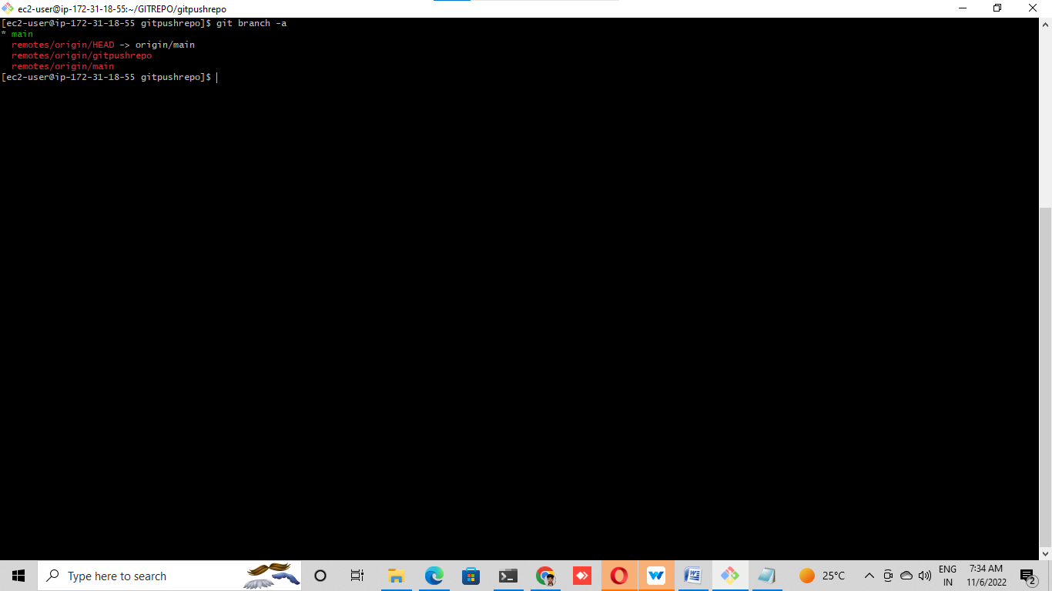

# Checkout to the feature branch or the branch that you created in (Lab – 6).

# a. git checkout

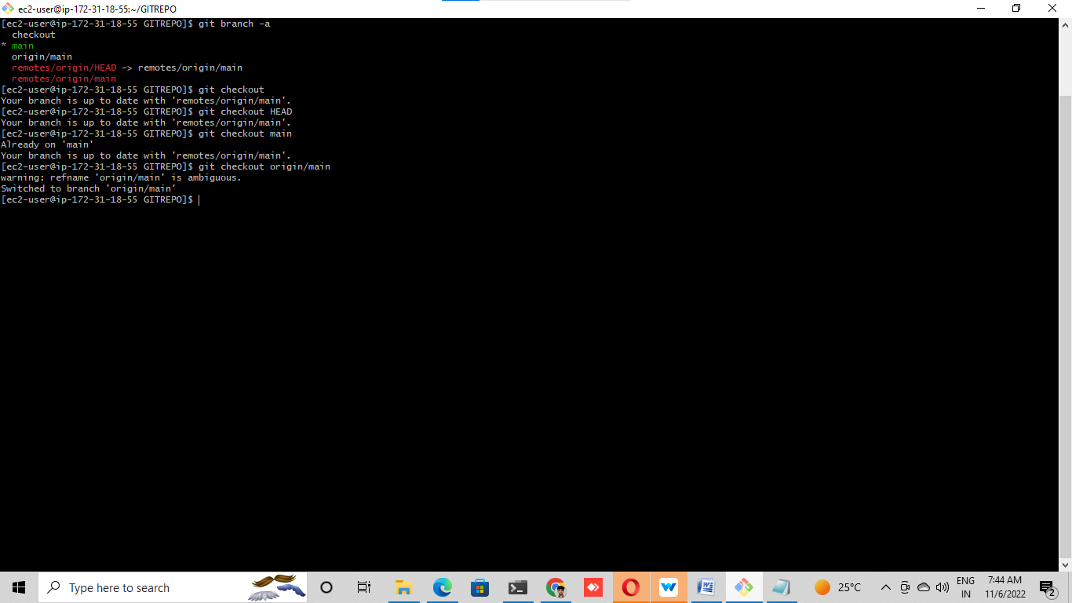

# Make sure that you are on the new branch by running git status or git branch

# command (notice the * mark)

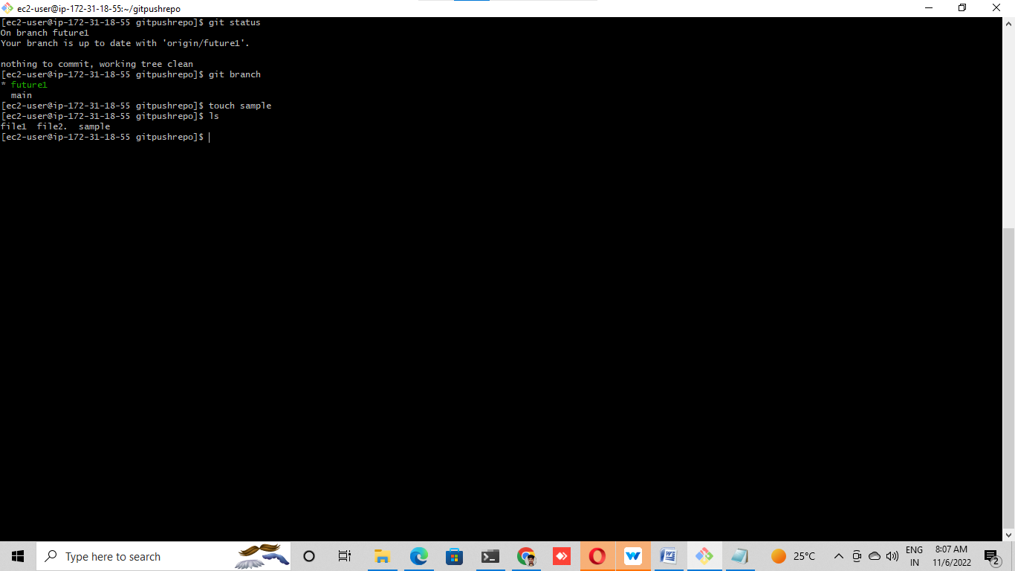

# Git add and status

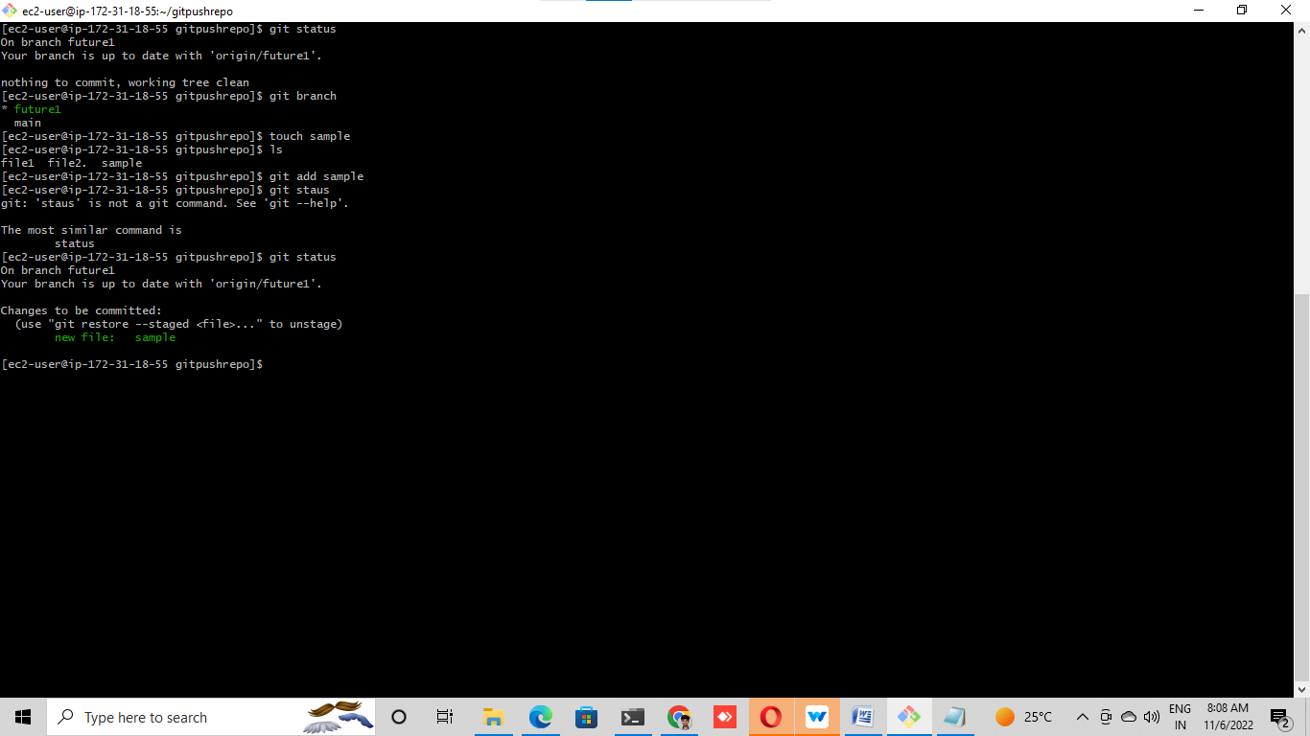

# git commit -m "added one file into branch”

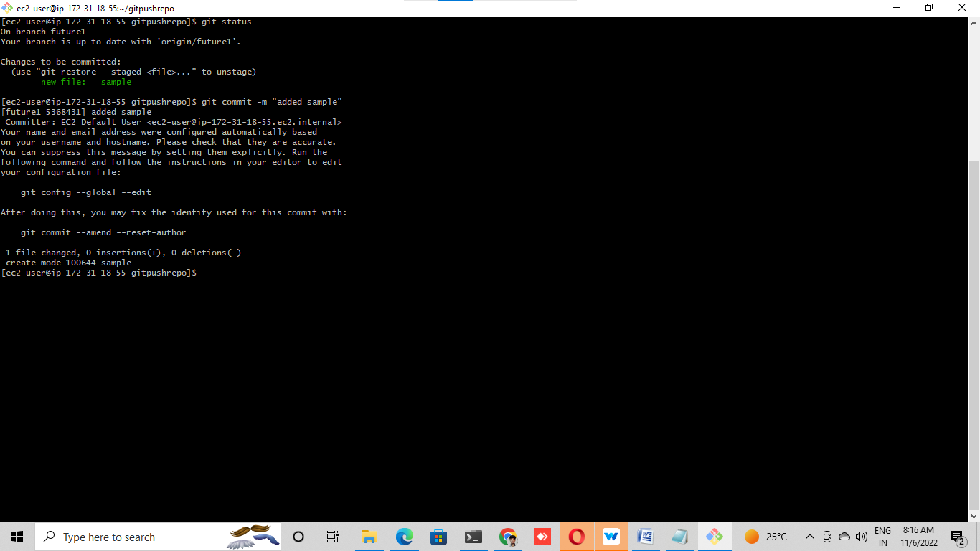

# Git push

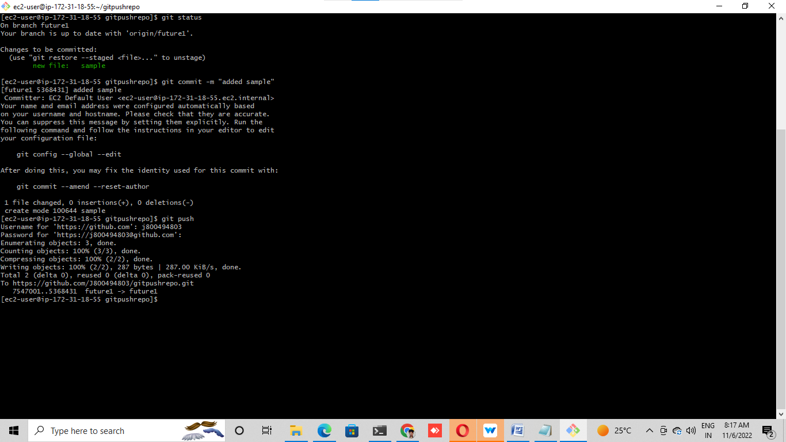

# Go to your GitHub portal once again

# ®Here see that the new changes are only available in your feature branch but not in

# the main branch

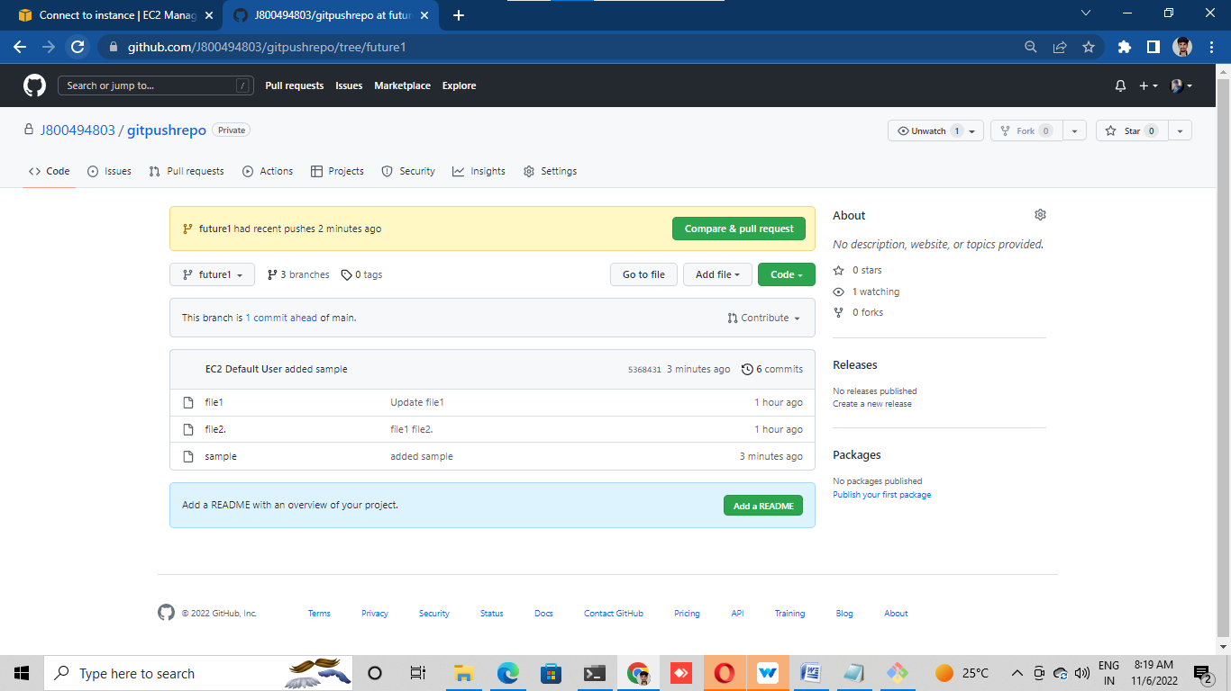

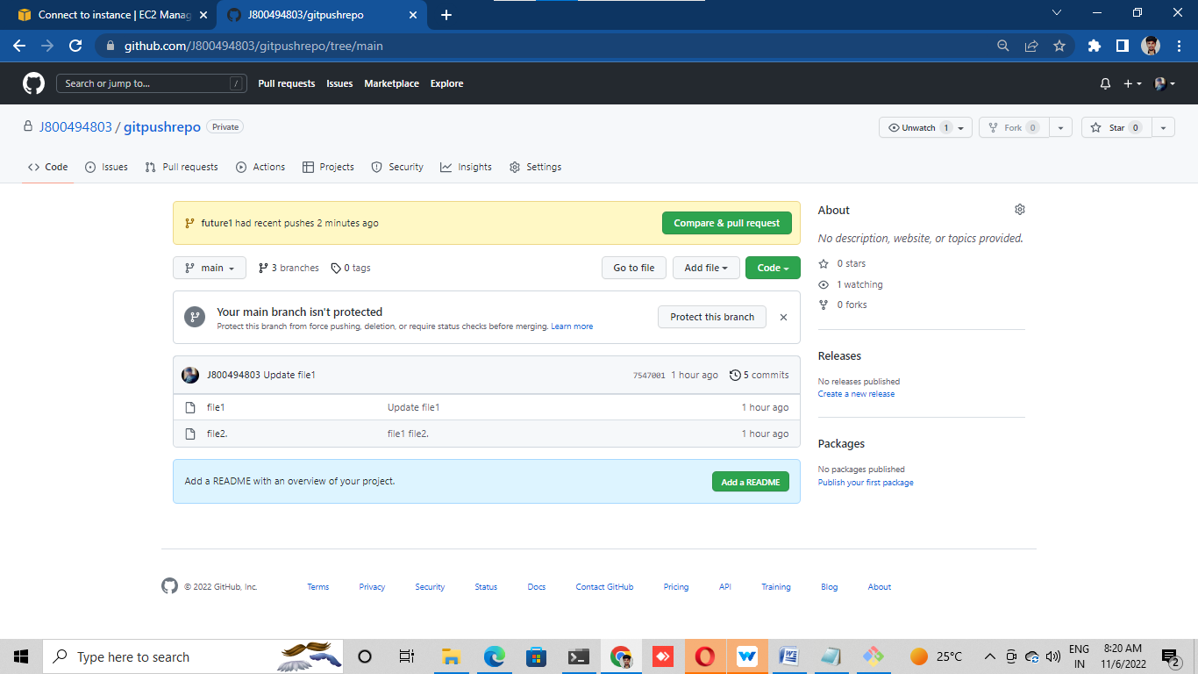

# Lab 8: (Merge our feature branch with main branch):

# ® Go to your GitHub repository

# ® Check the changes in your feature branch (Lab – 7)

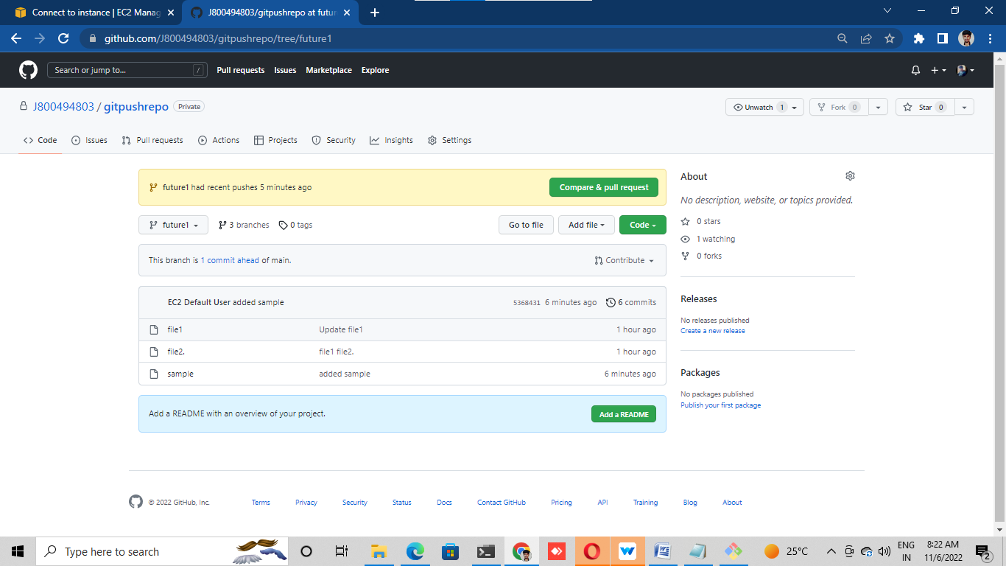

# Go to the pull request tab and click on create Pull Request (PR

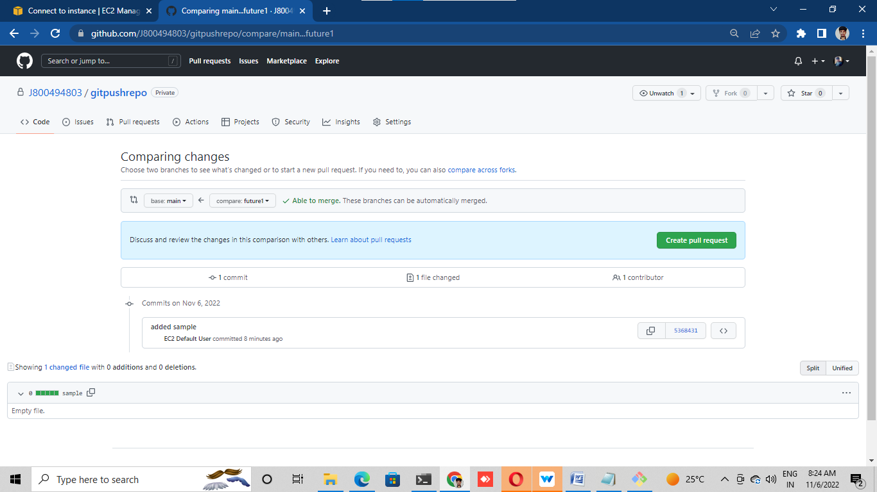

# Put your main branch (where u want to merge / destination) and the feature

# branch in the respective blocks.

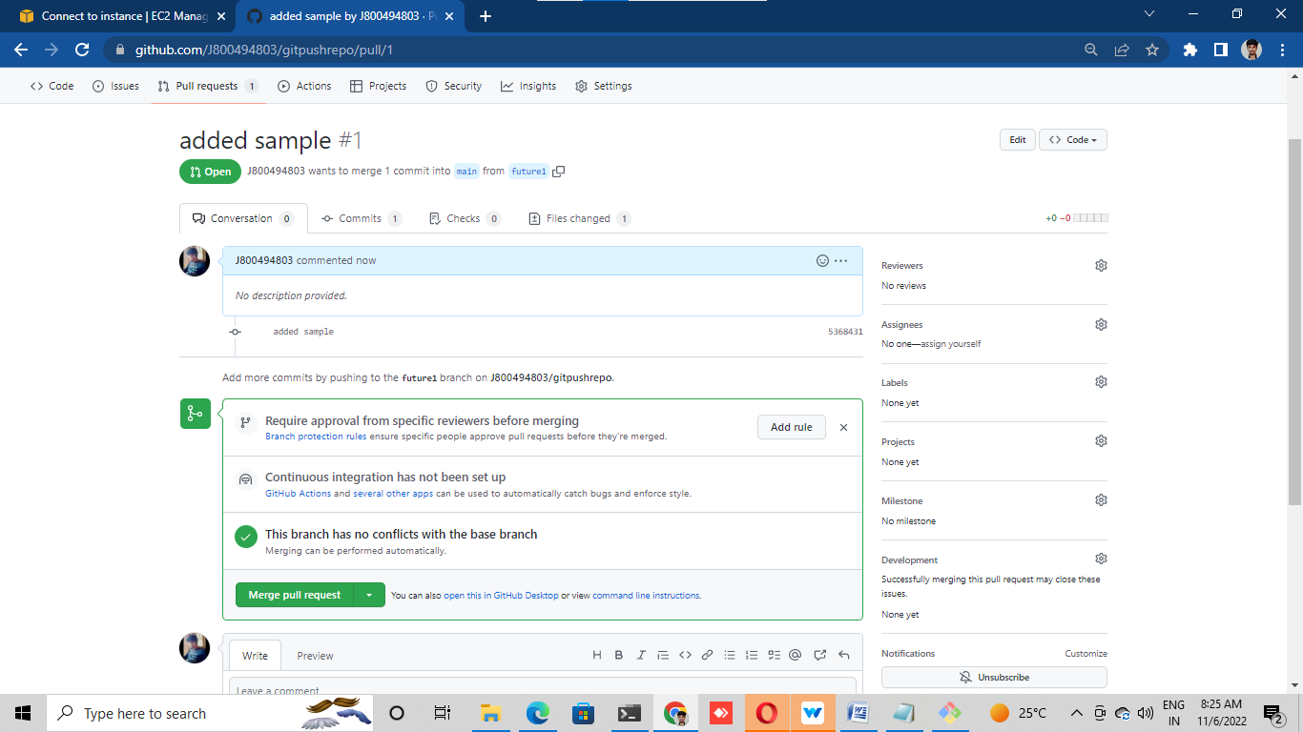

# Click on review changes and then merge.

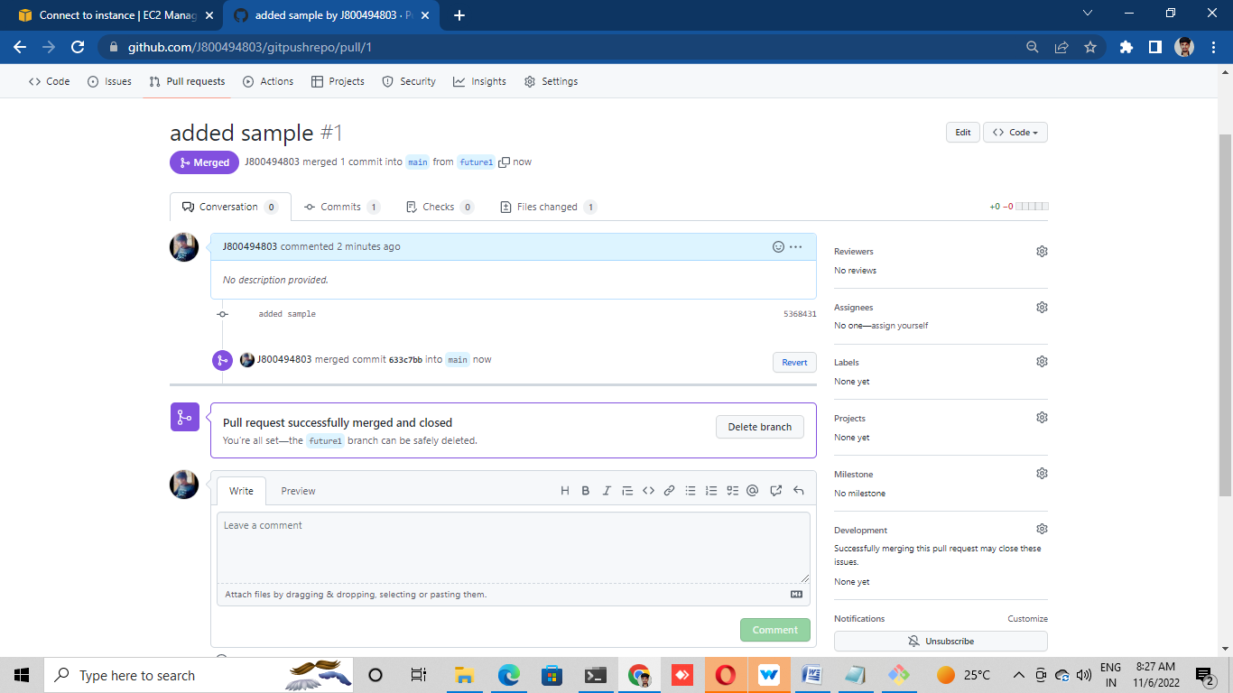

# Once done, you can delete this feature branch if required or you can simply ignore it.

# Go to your code in main branch and see the changes are now visible here.

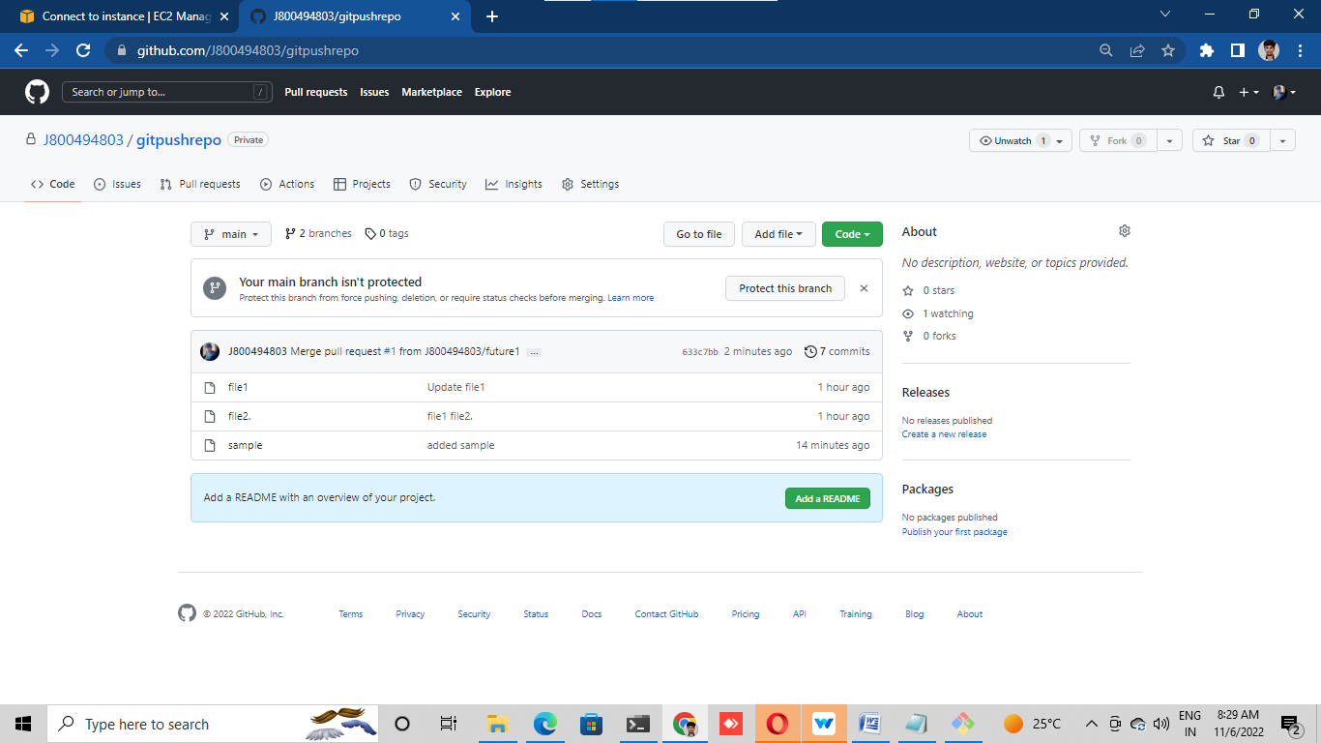

# Lab 9: (Go to local machine)

# Go to your local machine where you have the copy of your remote repo (Lab – 7).

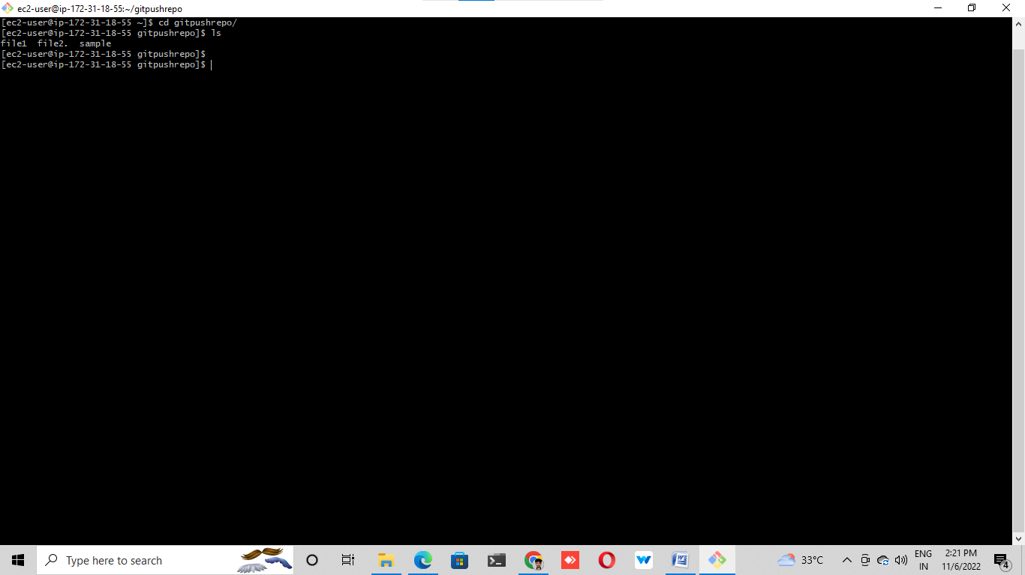

# Checkout to the main branch

# a. git checkout<branch name>

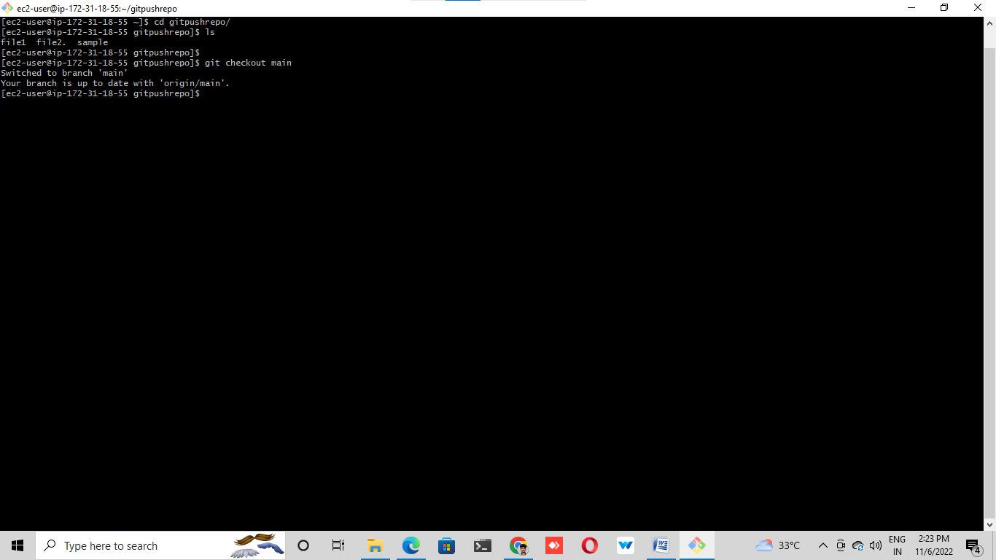

# Now run the command "git pull" to pull all the new changes such as branches from

# the remote location

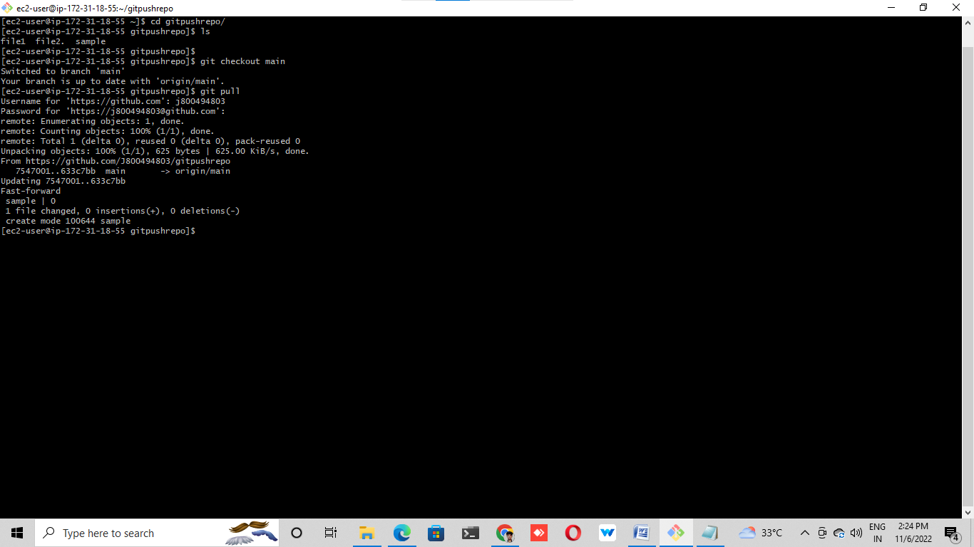

# Here see that the new changes are only available in your main branch

